**Gull Ahmed Mens kameez Shalwar Summer Collection**

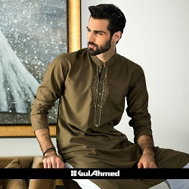

MEHNDI GREEN COLOR KURTA PAJAMA

PKR6992.00

* Jacquard Shirt: 3.5 Meters
* Trouser: 3.5 Meter

**MORE INFORMATION:**

* color: Mehndi green
* Wear Type: Semi-Formal
* Product Category: Semi-Formal Kameez Shalwar
* Volume : Volume 4 2021
* Collection: Festive Affair '22
* Fabric: Cottan
* Sizes: Small, Medium, Large
* Disclaimer: Due to the photographic lighting & different screen calibrations, the colors of the original product may slightly vary from the picture